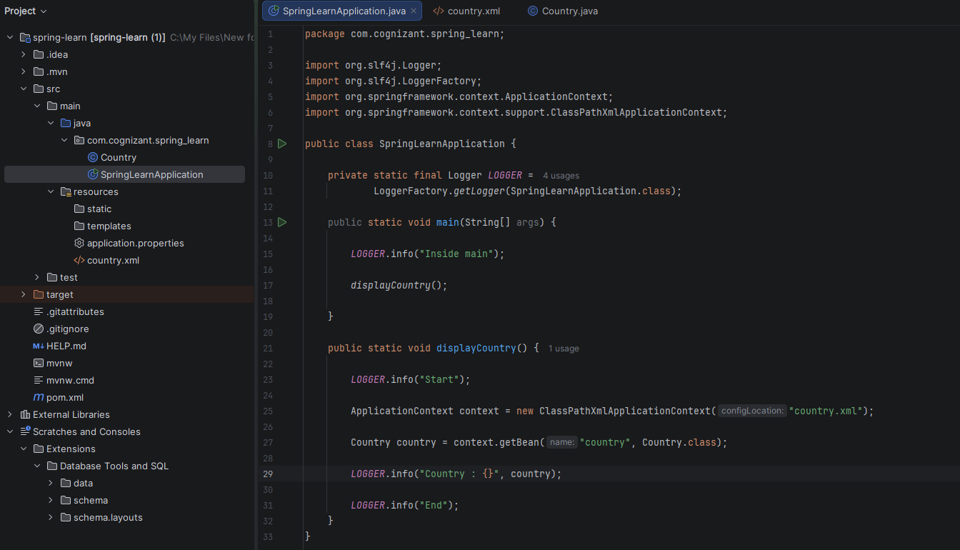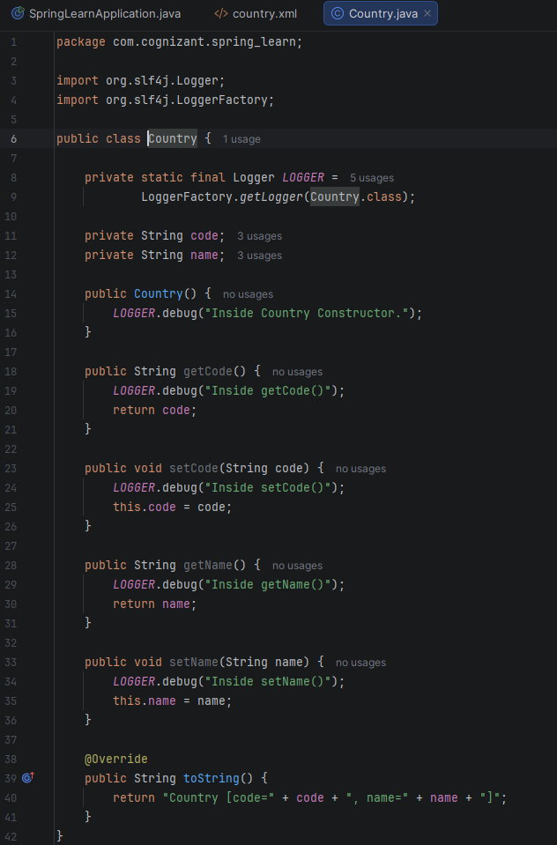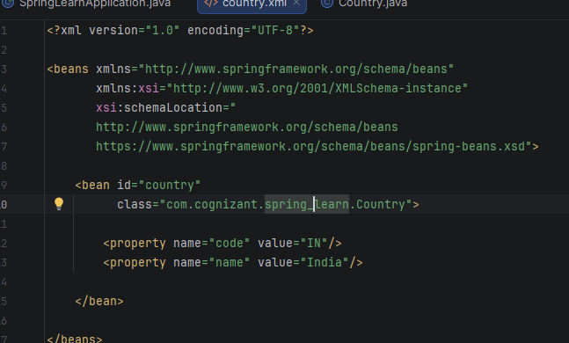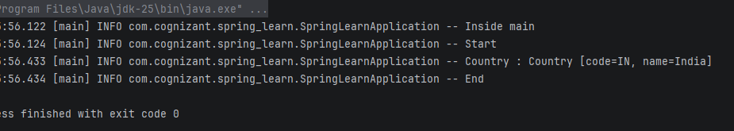

When context.getBean() is invoked, Spring:
- Looks for bean ID "country".
- If not already created , creates the object.
- Calls the constructor.
- Injects property values by calling the setters.
- Stores the bean in the IoC container.
- Returns the fully initialized object.

